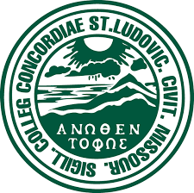
Concordia Seminary St. Louis
Logos Bible Software

$ 4,000

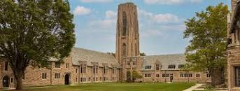

Concordia Seminary, St. Louis, Missouri - Logos Bible Software: This funding will assist students in paying for the initial, lifetime fee of Logos Bible Software of $650 per student. Our students, many of whom are married with children, typically live on tight budgets during their years of study. The elimination of the Logos software’s cost from their budgets is a much-welcomed relief to them.

2022-2024 Biennium – LWML Washington-Alaska District

